

Major Grant Application
Please answer all of the questions. Attach additional documents if necessary. Once complete, save as a word document and email to grant@brookfieldeducationfoundation.org.

Project Title: Entrepreneurship – How To Start A Business
Name of Applicant, Group or School: Career and Technical Education Department, Brookfield High School
Address: 45 Longmeadow Hill Rd. Brookfield High School Brookfield, CT 06488
Contact Person: Robert Zapor
Title: Team Leader, Career and Technical Education Department
Phone: 203-775-7725 x4403
E-mail: zaporr@brookfieldps.org
Fax: 203-775-7757
Total Amount Requested: $13,770
Date funds will need to be available: December 2017

Project Description:
- Project Overview: Each year the members of DECA (Distributive Education Club of America) attend several field trips and the National competition, held in different parts of the country. These trips can be very expensive, and are funded by the student’s parents, and typical fundraising efforts. Members of the Career & Technical Education department sat down and had a discussion of how we could raise funds, while also making it a meaningful and educational experience for the students. We came up with the concept of having the students start and run their own business, and use the profits to help offset the cost of these trips. After some consideration we focused on a Laser Engraving/Cutting business. This choice was made because it allows for an easy change in the product the students could choose to manufacture and sell each year without a need to change or add equipment. This program will not just raise funds, but will give the students the opportunity to develop entrepreneurial, technical, and business skills as well as develop and run a business much as would be done in the real world. Students will be required to research, develop, create and market a product for their laser engraving-cutting business. They will be responsible for running it and its ultimate success or failure. We anticipate profits may vary wildly from year to year based on the student’s decisions, but they will never suffer a real “loss” as the experiences they gain will be invaluable.

2. Community Impact: Students will develop skills in how to start and run various aspects of a business.
While not all students will work in all areas, they will be exposed to the following subject information:
Business Structure: Sole proprietorship, partnership, corporations, LLC’s
Creating a business plan
Researching and developing intellectual property
Evaluating demand for the product
Calculating pricing: operational cost and profit margins
Marketing: Customer acquisition, Website creation, commercials, flyers, business cards, etc.
Using correct accounting practices to track credits and debits
Learning technical skills and receiving certification in laser safety operation
Managing production and distribution
Possible additional impacts- Depending on the product the business club students may work with the art club or art classes for the design aspect of their product allowing for cross disciplinary collaboration.
The business clubs could work with other clubs, teams, and community groups to produce items which would benefit both groups.
As a thank you, items could be made for the BEF ( Not a bribe )

3. Evaluation: At the end of each year we will conduct a student survey which will ask students to discuss what impact the program had on them, and how they feel it could be improved to better meet their needs. While in part the success will be seen in how well the students were able to set-up and operate a business, to produce and market a sellable product, it is the experience they had, and how much benefit it had on them which will be our most valuable evaluative tool.

4. Project Duration: This would be yearlong project beginning in the fall after the first DECA meeting with the goal of completing manufacturing and sales before the annual conference in April, but would continue until late May or early June. It will be repeated from the beginning each year. Students who participated the previous year may choose to stay in the same area they worked to increase their knowledge or may choose to expand their experience by focusing in another area/aspect of running the business.

5. Future Implications: This program utilizes Brookfield High School’s core values of research, critical thinking, communication, collaboration and active involvement. Through this practical experience students who participate in this program will gain invaluable first-hand knowledge of how to apply the theory of business practice in the real world while developing a skill set which will benefit them throughout their careers.

6. Project Budget:

 | ITEM |  | COST
1 | Full Spectrum P Series 36x24 120W CO2 Laser |  | 10,995.00
2 | Rotary Attachment (option) |  | 1,000.00
3 | Focal Lenses 1.5” and 2” |  | 500.00
4 | Radiator Water Chiller |  | 600.00
5 | Estimated Shipping |  | 675.00
6
 |  | TOTAL COST | 13,770.00
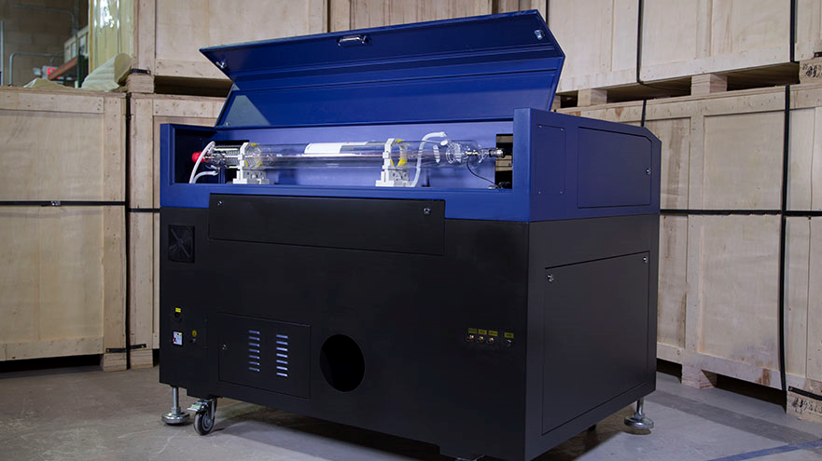 The 36x24 inch platform of this laser allows for a large 2’ x 3’ work area, but can accommodate larger materials with a pass through. The 120 watt laser tube allows for fast single pass cutting through thick materials.
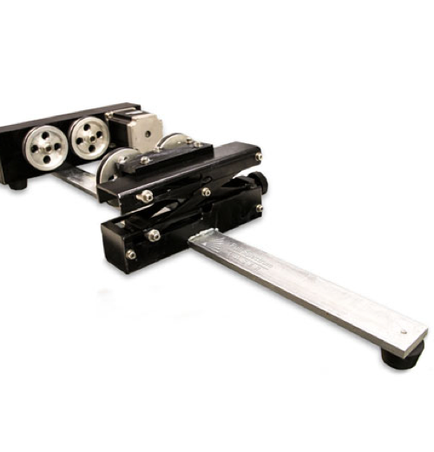 The rotary attachment allows for engraving on cylindrical objects such as glasses, and bottles. This is an option which could be added at a later date.

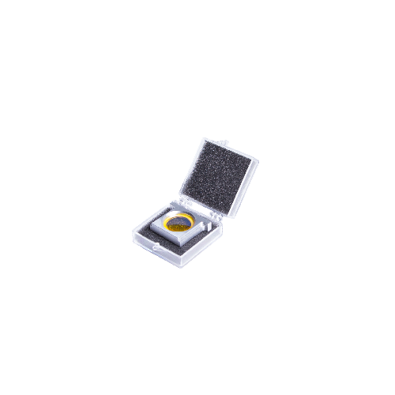The 1.5 focal lens is ideal for fine engraving, while the 2” is for better for cutting through materials.

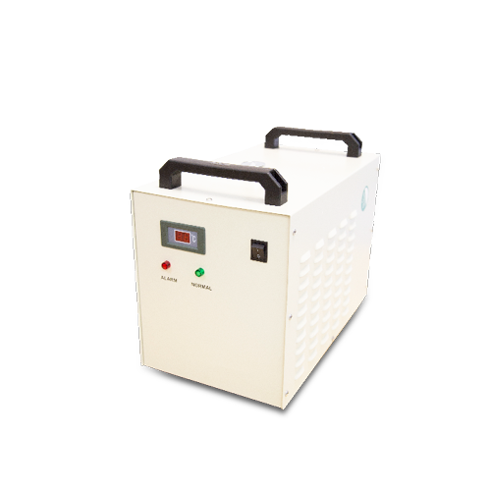Radiator water chiller cools the water which circulates around the laser tube for repeatable cut and engraving quality.

7. What prompted the idea for this proposal: Business, as part of the CTE Department has had a DECA chapter for many years. With the reestablishment of a second business teacher last year we discussed establishing a FBLA (Future Business Leaders of America) chapter. Both of these clubs will have a number of field trips and conferences for students to attend, and associated costs add up. In the past, students have done traditional school fundraisers and parents have made up the difference – sometimes several hundred dollars for a single trip. Adding another club means more fundraising that we couldn’t have conflict with DECA or any of the other fundraisers in the school. As a department we asked ourselves a number of questions. How could we increase fundraising without conflicting with other clubs? How do we make sure the students are actively involved? Is there a way to get the students not only to participate, but to be invested in the process? The answer was in the name “Business”. A successful business makes money. We feel if we can have students run their own business, they will not only raise money for their trips and activities, but they will earn it, while learning crucial business skills which will benefit them for their entire career. Choosing, producing and marketing a sellable product or service is key to success. Our next question was what kind of business could we have the students run which was relevant, flexible enough to allow change and have the students incorporate their own ideas? Our answer was a laser cutter/engraver. This system would have fixed set up costs, develop useful technical skills, and allow for many different products, both custom and mass produced. (See below)

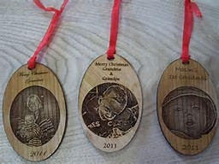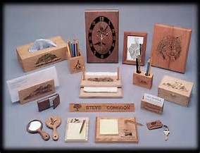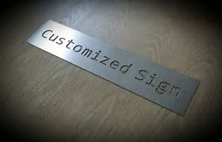

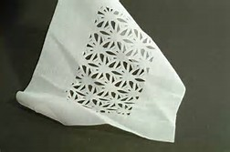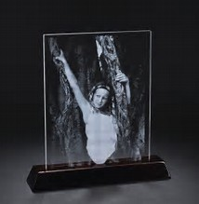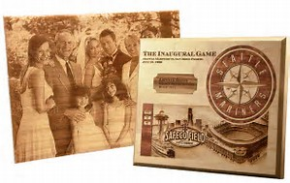

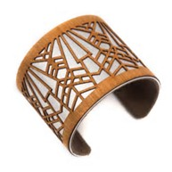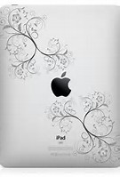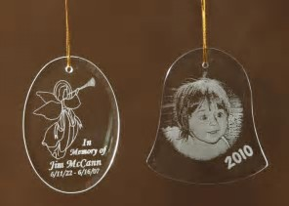

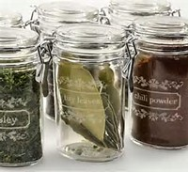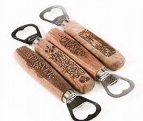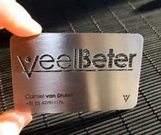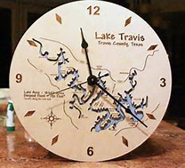

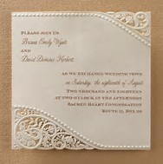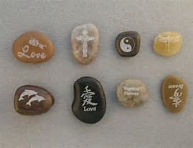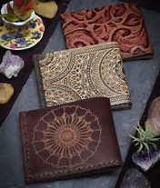

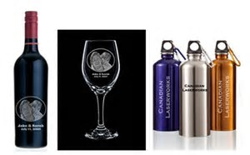

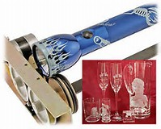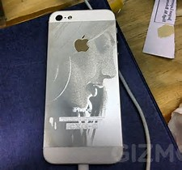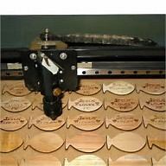

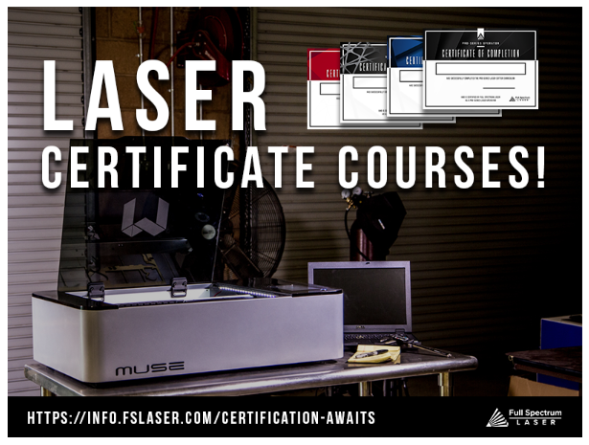

Applicant’s signature if not sent electronically: _______________________________________
Date: __________

Principal’s signature if applicable: __________________________________________________
Date: __________

If mailed, send to: Brookfield Education Foundation
PO Box 5047
Brookfield, CT 06804

